Internship Summary
Tanishk Varshney
(Special projects intern)
Four weeks at a glance
WEEK 1  Gaining access of tools  Process discovery  Procurement flow | → | WEEK 2  Contract/block tool  Reusable configs  AIS handoff | → | WEEK 3  AirOps workflow  CXO AI proposal  Data discovery | → | WEEK 4  Inventory Monitor(AirOps)  CXO AI field map  Holidays data joins

AirOps
Project at glance
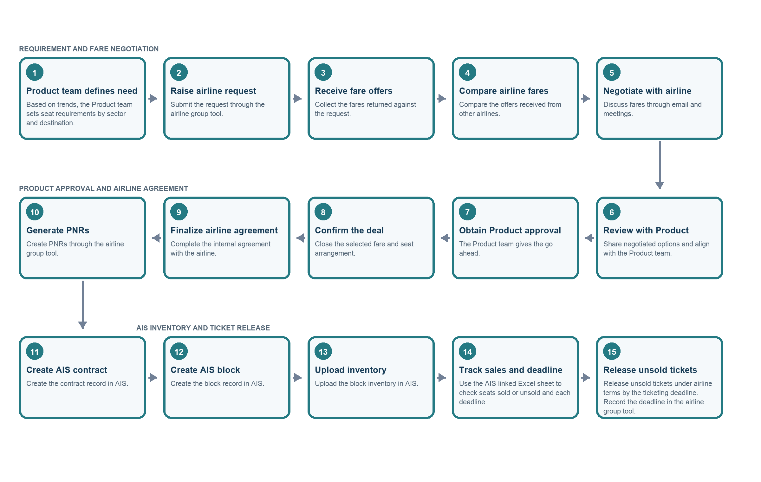
Weekly Updates
- Week 1 & 2: Process understanding and contract/block preparation
Mapped the existing AirOps process. The work began with understanding how the team moves from airline ticket procurement to AIS contract creation, block preparation, and inventory release. This helped identify where employees were repeatedly transferring information between sheets, filling templates, and checking data manually.
Identified automation opportunities. The early focus was on automating the preparation work around AIS:
- Turn procurement-sheet data into contract-upload rows.
- Use contract and procurement information to prepare block-upload rows.
- Add checks for missing, inconsistent, or conflicting data before employees upload files.
- Keep operator review for fields or decisions that cannot be safely inferred.
Started building the contract and block preparation tool. The prototype was shaped around two outputs:
- Contract creation: read the employee’s procurement information, map it into an AIS contract template, and produce a reviewable upload file.
- Block creation: combine the procurement information with the AIS contract result, then prepare block-upload rows for review and download.
Designed reusable airline and block configurations. A key design decision was to store stable, reusable values in configurations rather than repeatedly entering them for every case:
- An Airline Configuration stores airline-specific terms and reusable contract information.
- A Block Configuration stores reusable block values and the expected block-upload template structure.
- These configurations act as templates that employees can review and update when the underlying rules or formats change.
Separated reusable values from case-specific information. For each new procurement, the tool is intended to fetch changing details from the employee’s working procurement sheet—such as PNRs, routes, travel dates, and fares where available. It then combines those details with the saved airline or block configuration to prepare the output. This reduces repeated data entry while keeping each contract and block tied to its source procurement.
Worked toward an end-to-end contract and block flow. The intended sequence was:
- Employee prepares or receives the procurement sheet.
- The tool reads and organizes procurement details.
- The employee selects the relevant airline configuration.
- The tool prepares contract rows for review and export.
- The contract file is uploaded to AIS, where AIS generates contract IDs.
- The employee provides the AIS result alongside the procurement information and block template.
- The tool associates contract IDs with the relevant procurement groups and prepares block rows.
- The employee reviews the block output and uploads it to AIS.
Main blocker: AIS connectivity. The prototype can prepare files, but it does not connect directly to AIS to create contracts, retrieve generated contract IDs, or submit blocks. The process therefore still depends on employees uploading files to AIS and bringing the resulting data back into the tool. AIS access, integration options, and upload requirements remain dependencies for making the workflow fully connected.

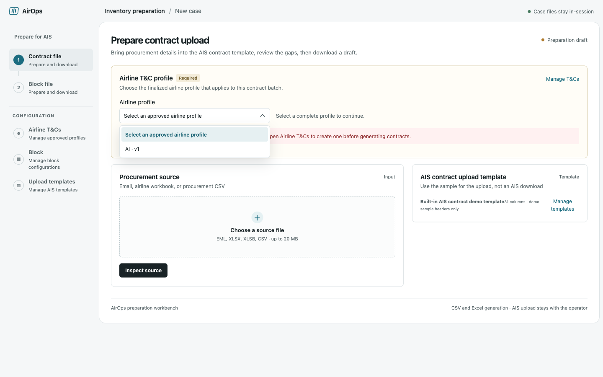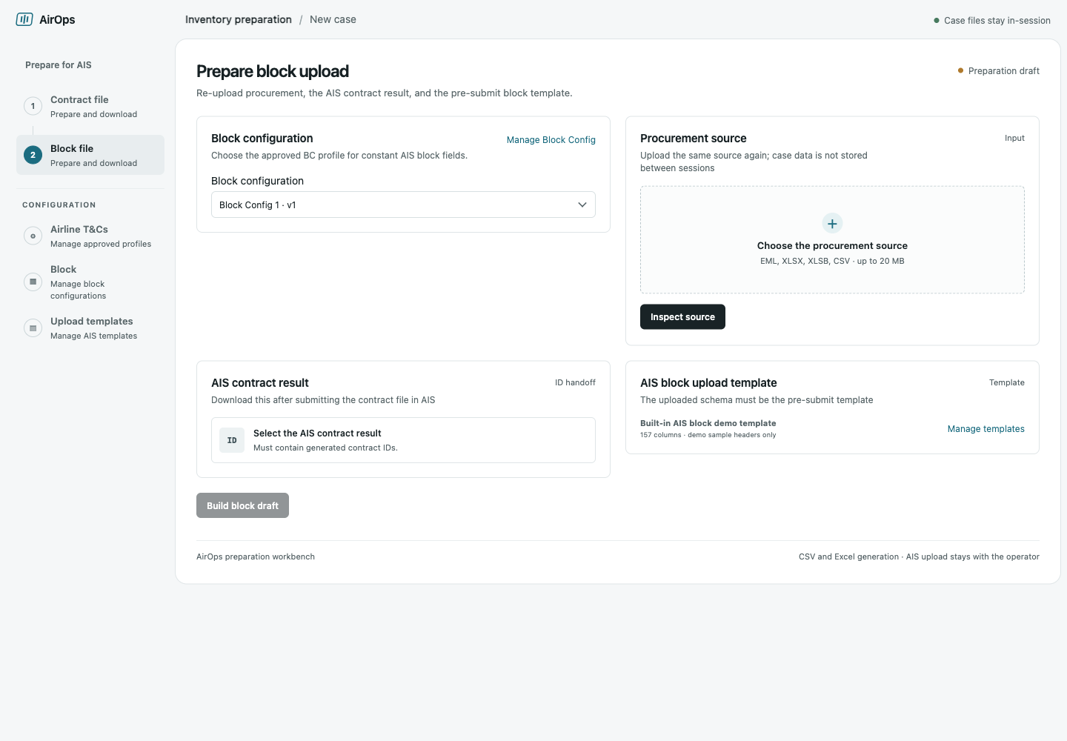

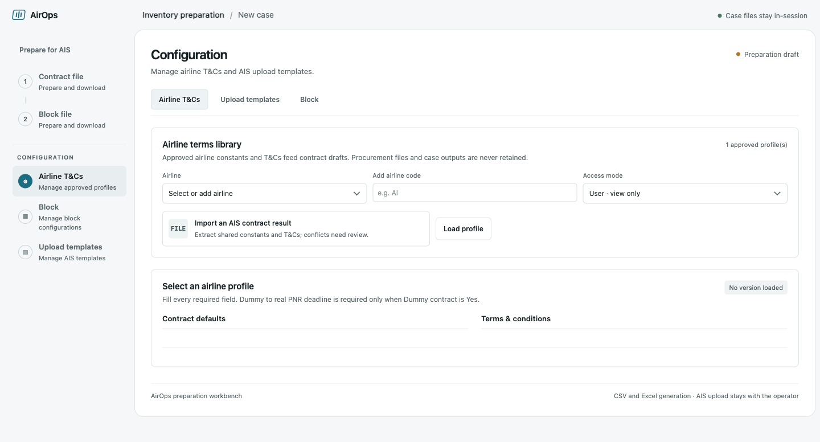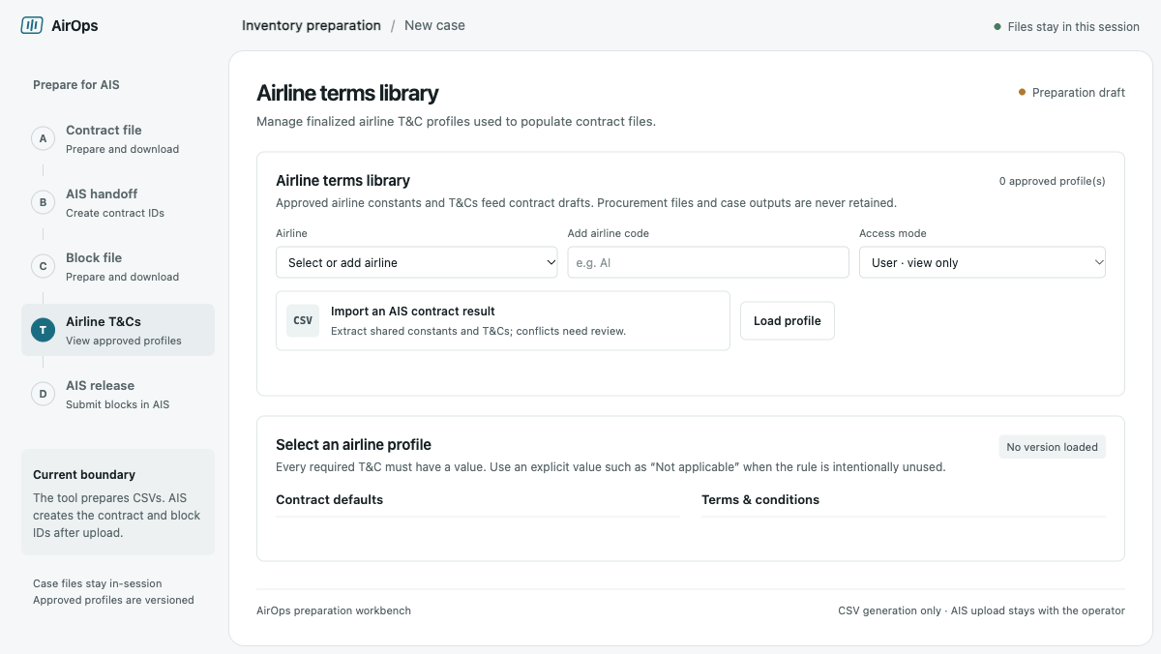

- Week 3: Defining the end-to-end AirOps workflow
Mapped the process from seat demand through inventory release.
- Product reviews trends and identifies seat requirements by sector and destination.
- Product shares the requested seat count with the Airline team.
- The Airline team raises requests through airline group tools, receives quotations, and compares fares across airlines.
- The Airline team negotiates with airlines and coordinates with Product.
- Product approves the selection; the airline is finalized and an internal agreement is made.
- The Airline team generates PNRs against the selected request IDs and flight times.
- The team creates the AIS contract and block, then uploads inventory.
- SPOCs track sold and unsold seats and deadlines in the working spreadsheet and/or AIS.
- SPOCs discuss deadline extensions with airlines and ask Product whether unsold seats should be retained or released.
- SPOCs are associated with sectors. The team consists of domestic coverage as roughly 3–4 people, with around 6–8 people overall including international coverage.
Documented the post-inventory tracking process.
- The working spreadsheet is connected to holiday-package sales data.
- After inventory is uploaded, the spreadsheet and/or AIS are used to monitor daily deadlines and sold/unsold seats.
- The SPOC coordinates with the airline about extending deadlines and shares the situation with Product.
Noted down the screens to be made for the end-to-end platform.

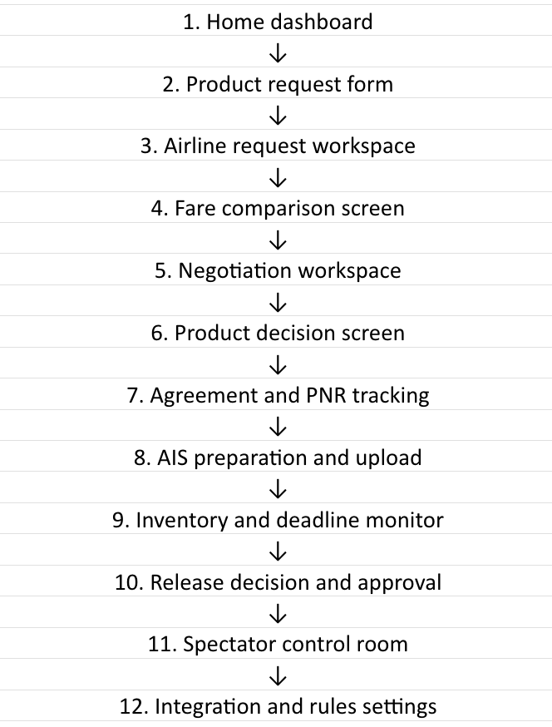

- Week 4: Inventory Monitor and end-to-end app structure
Built on a fuller understanding of post-inventory work.
- After blocks are uploaded, employees use the AIS-connected Excel sheet and/or AIS to track seats sold, available seats, and deadlines.
- SPOCs review their sectors, discuss deadline extensions with airlines, and share updates with Product, which decides whether unsold seats should be retained or released.
- The Inventory Monitor was designed to make this information easier to review within the AirOps app.
Reviewed data sources for the monitor.
- Compared Redash queries 105113, 156206, and 105126 for their data, filters, and suitability.
- Selected query 156206 as the main source as it supports filtering and provides block, flight, and inventory information.
- Identified that booking dates alone do not establish the airline’s actual ticketing deadline, so the authoritative source still needs confirmation.
Added the Inventory Monitor screen to the app.
- Added Metrics, Deadlines, and Flights & blocks views.
- The monitor loads active inventory across sectors by default. Users can fetch all sectors for a date range or select a sector without dates.
- Displays total seats, sold seats, available seats, and upcoming ticketing and release deadlines.
- Data is fetched in bounded date slices to reduce the risk of silent truncation at Redash’s row limit.
- Metrics use all fetched rows. The detailed flight table displays up to 2,000 rows and indicates when more are available.
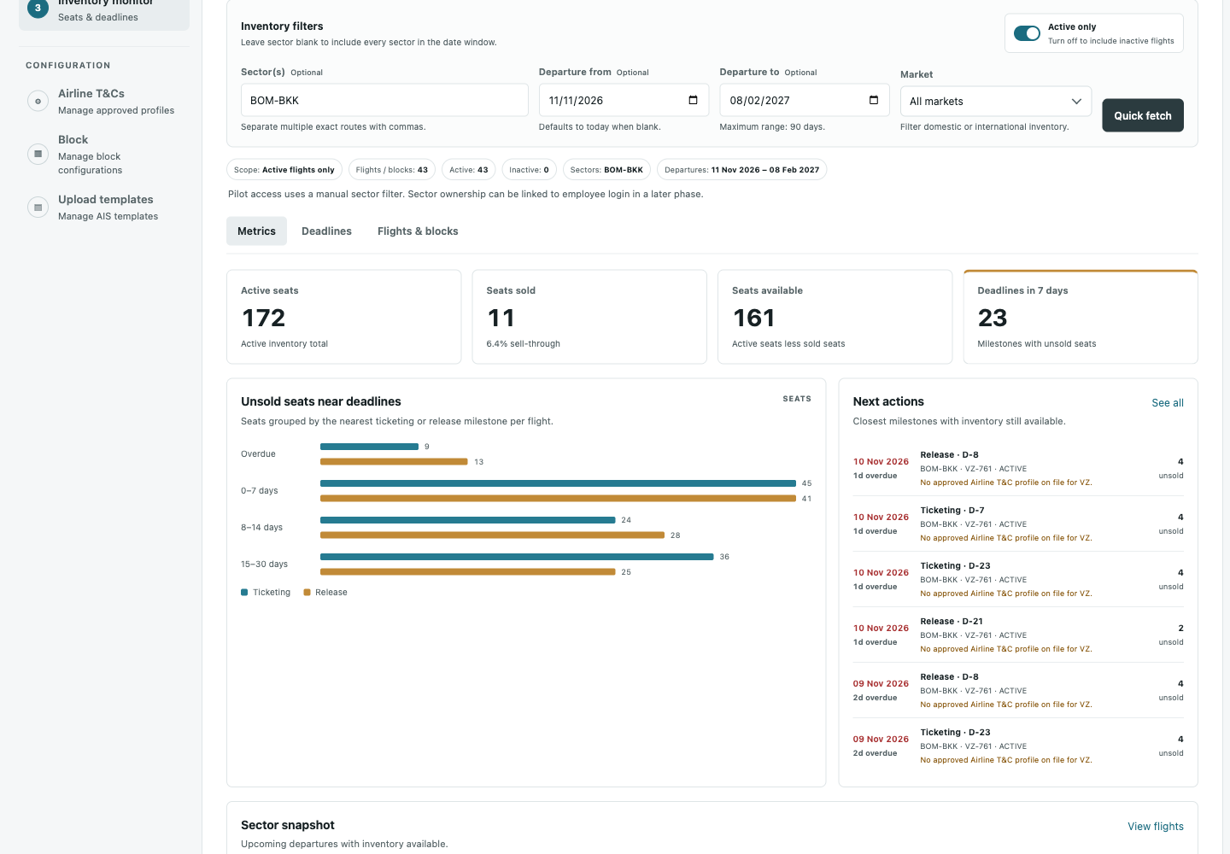

Further steps this week
Finish defining the complete app framework around the end-to-end process.
- Establish the app’s screens, navigation, user roles, handoffs, and status flow from Product’s seat requirement through airline coordination, fare review, agreement, PNR generation, AIS contract and block preparation, inventory tracking, and the retain-or-release decision.
- Show which team acts at each stage, what information they provide or review, and what outcome moves the work to the next stage.
- Make the full process visible in the app structure, even where some steps are still carried out manually.
Defer external integrations while defining the workflow.
- AIS connectivity and connections to airline group tools will come later(side by side will be working to get that access).
- For now, define where those systems fit, what information enters or leaves AirOps, and where a person completes the handoff.
- Keep the structure ready for those integrations without making them prerequisites for defining the app’s end-to-end flow.

CXO AI
Project at a glance
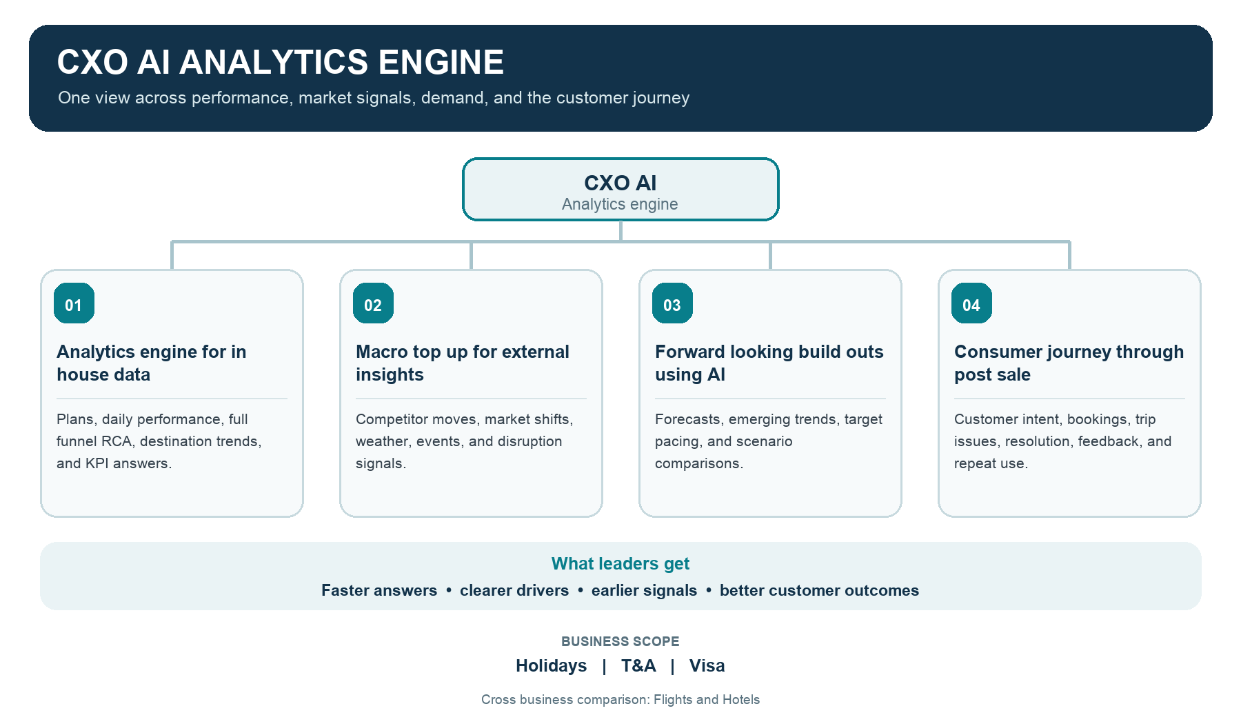
Weekly Updates

Week 3: Getting an understanding of CXO AI and gathering data
doc links: CXO AI Project Brief
Understood the CXO AI vision and the business questions it should support.
- Organized the project into four areas: internal business analytics, macro and market insights, AI-supported forward-looking analysis, and the customer journey through post-booking.
- Set the scope across Holidays, TNA, and Visa, with potential comparisons to related areas such as Flights and Hotels.
- Focused on developing a solution to help leaders answer questions about performance against targets, changes in results, root causes, destination performance, and customer behaviour.
Prepared for discussions with the business teams.
- Started coordinating meetings with Holidays and TnA teams to understand their day-to-day questions, decisions, reports, and data sources.
- Prepared questions about metric definitions, data ownership, date fields, data detail, refresh frequency, historical coverage, and available filters.
- Began reviewing the queries shared for Holidays, including quote, booking, ticket-detail, and shopper data.
- Identified areas to clarify, such as whether similarly named fields have the same meaning across queries and which dates should be used for reporting.

Week 4: Understanding the data across verticals

doc links: Holidays Data
Queries & Fields Received
Collected the TNA query archive.
- Reviewed what each query can support, including its measures, date grain, dimensions, and filters.
- Noted where the available date range or fields may limit an analysis.
Prepared a comprehensive Holidays data reference.
- Brought together the Holidays query and data information in a larger reference document.
- Summarized the areas covered: quotes and bookings, ticket details, shopper and cohort behavior, funnel conversion, and advance-purchase patterns.
- Used the review to identify where field definitions, date logic, and relationships between datasets need confirmation.
Created a spreadsheet of fields from the queries received.
- Listed the fields returned by the queries in one place.
- Added notes on date fields, data grain, available dimensions and filters, and how datasets might connect.
Continued coordinating discussions with the business teams.
- Used the query reviews to make follow-up discussions more specific.
- Focused on confirming how each team defines its metrics, which dates it uses, how current the data is, and whether the available fields can answer the questions the team needs answered.
Further steps this week
Build helper data joins to connect related datasets within Holidays.
- Identify the shared keys that can link the different Holidays data areas, such as quotes, bookings, shopper activity, and ticket details.
- Confirm what each key represents and whether it links records one-to-one or one-to-many before using it to combine data.
- Document the approved joins, date fields, and grain so cross-vertical analysis uses consistent rules.
- Use these helper joins to support questions that span the Holidays journey, while keeping the original query sources and their definitions clear.

